A Project Report

Books Inventory System

Punjab University, Chandigarh

In The Partial Fulfillment For The Award Of The Degree

Of

Master Of Science

(Information Technology)

Under The Esteemed Guidance Of

Mrs. Nisha Gupta, M.Sc. (Hons.) CS, MCA


Assistant Professor

POST GRADUATE GOVERNMENT COLLEGE, SECTOR 11, CHD.

DEPARTMENT OF PROFESSIONAL STUDIES
(2025-2027)
SUBMITTED TO: SUBMITTED BY:
MRS. NISHA GUPTA Ma’am Aakashdeep Chrispin (4606/25)

Index

Sr. No | Topics | Page No
1. | Project Overview & Description | 1
2. | Flow Chart | 2
3. | E-R Diagram | 3
4. | Future Growth of the Project | 4
5. | Introduction to Perl Language | 5-7
6. | Project Code | 7-17
7 | Output | 17-20
8 | Conclusion | 20

Project Overview

Project Name- Book Inventory System
Language- Perl

Hardware & Software Requirement

Software- Perl Environment
Hardware- Windows, Mac, Linux OS

Project Description

The goal of this project is to maintain books inventory and order new books if stock of the books gets less, this system can be very helpful in various places such as a book shop, a library, reading centers of various institutes.

The goal is to help the user keep a database of the books in stored format, to maintain efficiency and enhance the workflow of a book environment(book store, library etc).

The back-end relies on flat-file storage (such as text or CSV files) in this project I have used .txt file to save and retrieve records, ensuring the system remains lightweight and easily portable. Perl's strong text processing capabilities make it well-suited for this task.

Flow Chart

The Book store management process flowchart aims to give a clear understanding to the admin about the flow of process, the project goes through and what are the functions which the admin can do to manage the book store.
Here, the main menu contains the following attributes which are – Add Books, Search Books, Delete, Order Books, View Records.
Inventory functions which admin can perform are- adding new books, search books & order, delete order & record, View Record.

Main Menu
Main Menu
Add (Books)
View
Authenticate
Order
Change User ID

View Books

View Orders

Change Password

Exit

E-R Diagram

Entity Relationship Diagram shows the relationship between the attributes and objects. Here, the primary keys are – Author Name, Book Id, Publisher Name & Order Id.

Name
Name

Author
Written By
Publisher
Published By
Book
Book Id
Price
Title
Order
Order ID
Order Item
Inventory
Price
No of Copies
Add

Future Growth of the Project

There are few more functions which can be added in the future to the project.

1. Update and Delete Book Records
- Updating the existing book details (e.g., price, quantity, title) through the system can also be added in the future. Also, deletion of books functionality will further complete the whole data base management system.

2. Search and Filter
Currently, the user can view books and order records and implementing keyword-based search (by title, author, subject) will further upgrade the functionality. Searching of books can be done by adding filters for category such as availability, price range, etc.

3. User Management
Currently the project has only one user login implemented and allowing multiple user roles like Admin, Staff, Customer will further improve the accessibility of the system by multiple users.

4. Inventory Alerts
Inventory alerts are automated notifications or visual indicators that help staff or admins stay informed about the stock levels of books. The goal is to avoid stock outs (when a book is out of stock) or overstocking (when too many unsold books accumulate), ensuring smooth inventory management and timely restocking.

5. File Management Integration
Currently, the project database connectivity is with the notepad. Adding the connectivity with Excel File(.csv) can enable the data analytics functions to the system.

These future improvements can enhance the usability, scalability, performance, and overall value of the book management system.

Introduction to Perl Language

Perl is a high level interpreted and dynamic programming language.

- Perl supports both the Procedural and Object-Oriented programming.

- Perl is a lot similar to C syntactically and is easy for the users who have knowledge of C, C++.

- Perl code is typically interpreted, meaning that it is executed directly by the computer without the need for compilation. This can make development faster and more flexible, but can also lead to slower execution times for large programs.

Advantages

- It is very efficient in text-manipulation i.e. Regular Expression. It also provides the socket capability.

- It is free and a Open Source software.

- Flexibility: Perl is a flexible language that allows programmers to solve problems using a variety of approaches, making it easy to write code quickly and efficiently.

- Regular expressions: Perl has excellent support for regular expressions, which makes it ideal for text processing and data manipulation tasks.

- Large library of modules: Perl has a vast library of modules that can be used to extend its functionality, making it easy to add complex features to your programs without having to reinvent the wheel.

- Cross-platform support: Perl runs on a wide range of platforms, including Windows, Linux, macOS, and more.

Disadvantages

- Programs runs slowly and program needs to be interpreted each time when any changes are made.
- In Perl, the same result can be achieved in several different ways which make the code untidy as well as unreadable.

- Usability factor is lower when compared to other languages.

- Complex syntax: Perl's flexibility can also be a disadvantage, as it can lead to code that is difficult to read and maintain, especially for developers who are new to the language.

- Performance: Perl is an interpreted language, which means that it can be slower than compiled languages like C or Java for large or computationally intensive programs.

- Legacy code: Because Perl has been around for over 30 years, there is a lot of legacy code written in earlier versions of the language that may not be compatible with newer versions.

- Security: Perl has some security concerns, such as the possibility of code injection attacks if the input data is not properly sanitized.

Applications

- Web development: Perl is commonly used for server-side web development, with popular frameworks such as Catalyst and Dancer.
- Text processing: Perl's powerful regular expression support makes it ideal for text processing tasks.

- System administration: Perl is often used for system administration tasks, such as automating system backups, managing configuration files, and monitoring system resources.

- Network programming: Perl can be used for network programming, with modules available for tasks such as sending email, communicating with web services, and building network protocols.

- Bio-informatics: Perl is widely used in bio-informatics, with popular modules such as Bio-Perl providing a powerful toolkit for biological data analysis and manipulation.

- GUI development: Perl can be used for GUI development with toolkits such as Perl/Tk, allowing developers to create cross-platform desktop applications.

Project Code

$filename = "Books_Inventory.txt";
@records;
open $fh, '<', $filename;
$header=<$fh>;
chomp $header;
@headers=split(',', $header);
while ($line = <$fh>)
{
chomp $line;
@fields=split(',', $line);
%record;
for $i(0..$#headers)
{
$record{$headers[$i]}=$fields[$i];
}
push @records, \%record;
}
close $fh;

$orderfilename = "Books_Orders.txt";
@records;
open $fh, '<', $filename;
$header=<$fh>;
chomp $header;
@headers=split(',', $header);
while ($line = <$fh>)
{
chomp $line;
@fields=split(',', $line);
%record;
for $i(0..$#headers)
{
$record{$headers[$i]}=$fields[$i];
}
push @records, \%record;
}
close $fh;

sub Bookshoplogin
{
open($fh, '<', 'Login_Details.txt');
chomp($saved_id = <$fh>);
chomp($saved_password = <$fh>);
close($fh);
print ("-----Login----- \n");
print ("Enter the Login ID: \n");
chomp($login_id=<STDIN>);
print ("Enter the Password: \n");
chomp($login_password=<STDIN>);

if($login_id eq $saved_id && $login_password eq $saved_password)
{
print ("Login Successful \n");
mainmenu();
return;

}
else
{
print ("Incorrect Login ID And Password. Try Again \n");
Bookshoplogin();
}
}
sub mainmenu
{
print "\n === Welcome To Book Shop === \n";
print "Choose from the Options Below :\n";
print "1. Add \n";
print "2. Order \n";
print "3. Change Authentication \n";
print "4. View Details \n";
print "5. Exit \n";
print "Enter Your Choice: ";

chomp ($input = <STDIN>);

if ($input eq '1')
{
add();
}
elsif ($input eq '2')
{
Order();
}
elsif ($input eq '3')
{
authenticate();
}
elsif ($input eq '4')
{
View();
}
elsif ($input eq '5')
{
exit();
}
else
{
print ("Invalid choice. Please Select a Valid Option.\n");
mainmenu();
}
}
sub add
{
print ("\n Enter Book Title: ");
$title = <STDIN>;
print ("\n Enter Book ID: ");
$bookid = <STDIN>;
print ("\n Enter Author Name: ");
$author = <STDIN>;
print("\n Enter Publisher Name: ");
$publisher = <STDIN>;
print ("\n Enter Price: ");
$price = <STDIN>;
print ("\n Enter No of Copies: ");
$quantity = <STDIN>;

chomp($title, $bookid, $author, $publisher, $price, $quantity);
open($fh, '>>', $filename);
print $fh join(',', $title, $bookid, $author, $publisher, $price, $quantity) . "\n";
close($fh);
print ("\n New Book Data Added successfully to $filename \n");
mainmenu();
}
sub View
{
while (1)
{
print "Press 1 To View All the Books Records \n";
print "Press 2 To View Order Records \n";
print "Press 0 For Main Menu \n";
print "Enter Your Choice: \n";

chomp ($input = <STDIN>);

if ($input eq '1')
{
open $fh, '<', $filename;
printf "%-20s %-6s %-20s %-30s %-7s %-8s\n",
"Title", "ID", "Author", "Publisher", "Price", "Quantity";
print "-" x 100 . "\n";
while($line=<$fh>)
{
chomp($line);
($title, $bookid, $author, $publisher, $price, $quantity) = split /,/, $line;
printf "%-20s %-6s %-20s %-30s %-7s %-8s\n",
$title, $bookid, $author, $publisher, $price, $quantity;
}
close $fh;
}
elsif ($input eq '2')
{
open $fh, '<', $orderfilename;
printf "%-20s %-6s %-20s %-30s %-7s %-8s\n",
"Name", "Order Id", "Book Id", "Price", "Quantity", "Warehouse";
print "-" x 100 . "\n";
while($line=<$fh>)
{
chomp($line);
($name, $orderID, $book_id, $amount, $bookquantity, $selected_warehouse) = split /,/, $line;
printf "%-20s %-6s %-20s %-30s %-7s %-8s\n",
$name, $orderID, $book_id, $amount, $bookquantity, $selected_warehouse;
}
close $fh;
}
elsif ($input eq '0')
{
mainmenu();
}
else
{
print ("Invalid choice. Please Select a Valid Option.\n");
View();
}
}
}
sub Order
{
print ("Please Enter Your Name: \n");
$name = <STDIN>;
print ("Entered Name is: $name \n");
print ("Please Enter The Book ID: \n");
$book_id = <STDIN>;
chomp $book_id;
print ("Entered Book ID is: $book_id \n");
open $fh, '<', $filename;
$found=0;
while($line = <$fh>)
{
chomp $line;
@fields = split /,/, $line;
if ($fields[1] && $fields[1] eq $book_id)
{
print ("Book ID Found \n");
print ("$line \n");
$found = 1;
last;
}
}
close $fh;
if (!$found)
{
print "Book Not Available.\n";
mainmenu();
}
print ("Enter the Quantity: \n");
$bookquantity = <STDIN>;
print ("Entered Quantity is: $bookquantity \n");
print ("----- Warehouse ----- \n");

while(1)
{
print "Press 1 For ABC Warehouse \n";
print "Press 2 For CNBC Warehouse \n";
print ("Please Select the Warehouse: \n");

chomp ($input = <STDIN>);

if ($input eq '1')
{
$selected_warehouse="ABC Warehouse";
print ("Your Selected Warehouse is: ABC Warehouse \n");
last;
}
elsif ($input eq '2')
{
$selected_warehouse="CNBC Warehouse";
print ("Your Selected Warehouse is: CNBC Warehouse \n");
last;
}
else
{
print ("Please Enter the Correct Choice \n");
}
}

$orderfilename = "Books_Orders.txt";
open(my $fh, '>>', $orderfilename);
print $fh "Selected Warehouse: $selected_warehouse\n";
close $fh;

print ("Enter Book Amount For 1 Unit \n");
$bookamount = <STDIN>;
$amount=$bookquantity*$bookamount;

print ("Total Amount $amount \n");
$orderID = int (rand(20));
print ("Thank You $name Your Order has been Placed Successfully. \n");
print ("Please Note Down The Order Number: $orderID for Futher Reference. \n");
orderdata();

sub orderdata
{
$orderfilename = "Books_Orders.txt";
chomp($name, $orderID, $book_id, $amount, $bookquantity, $selected_warehouse);
open($fh, '>>', $orderfilename);
print $fh join(',', $name, $orderID, $book_id, $amount, $bookquantity, $selected_warehouse) . "\n";
close($fh);
mainmenu();
}
}
sub authenticate
{
print("Enter New User ID: \n");
chomp($loginid=<STDIN>);
print("Enter New Password: \n");
chomp($loginpassword=<STDIN>);
open($fh, '>', 'Login_Details.txt');
print $fh "$loginid\n$loginpassword\n";
close $fh;
print("User ID and Password Changed");
}
Bookshoplogin();

sub exit
{
exit(0);
}

Output (Screenshots)

First, the user needs to enter the Login ID And Password to access the menu.

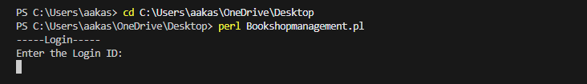

After entering the Login id and Password the user is granted access to the menu.
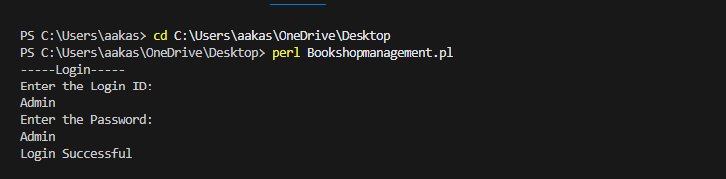
Menu
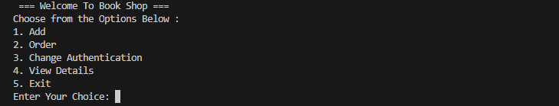
Adding New Book to the inventory
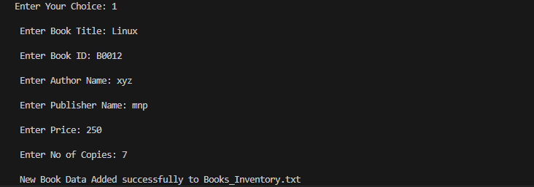
Changing User Id And Password
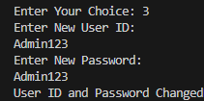

Ordering new book for the inventory
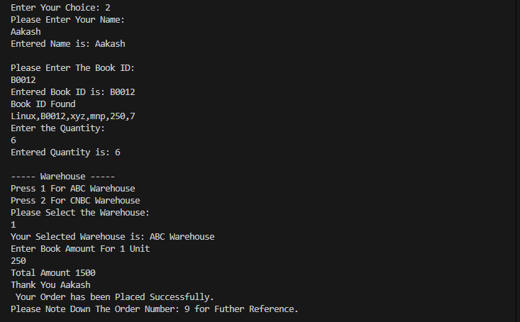
Viewing Books Record currently in the Inventory
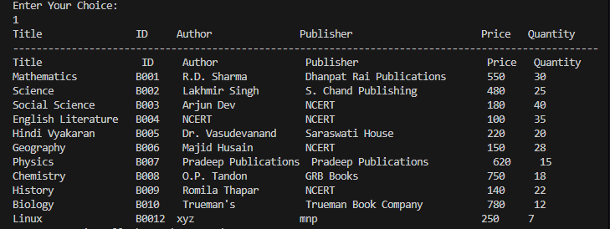

Viewing Books Order Records
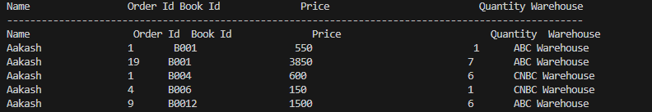

Conclusion

The Books Inventory System developed using the Perl programming language provides a functional and efficient solution for managing a small to medium-sized book inventory. The system has the inventory management functionalities, including:

- Adding New Books: Users can seamlessly add new books to the inventory database, ensuring the collection remains up to date.

- Ordering Books: The system allows users to place orders for new stock, with each order being recorded and stored in the database for tracking and future reference.

- Viewing Records: Comprehensive viewing capabilities are provided to review both current inventory and ordered books, enhancing transparency and control.

- User Credential Management: Users can change their user ID and password, adding a layer of personalization and security to the system.

This Perl-based system demonstrates the flexibility and utility of scripting languages in building reliable and straightforward inventory solutions. While it serves its purpose effectively, it also offers a strong foundation for further enhancements, such as integrating a user-friendly GUI or implementing advanced search and filtering features. Overall, it streamlines essential book inventory processes and is a valuable tool for managing book data efficiently.

